#### Method 1 (Preferred): Link and Retrace

* Link a DWG temporarily into a Drafting View. Change the drafting view scale to match the DWG detail.
* Retrace geometry with standard Revit lines. Use the Pick Lines drafting line option to speed up the process. (See figure below.)
* Use standard Fill Regions when appropriate.
* Identify opportunities to use Detail Components: Avoid retracing geometry that can be a Revit detail component (i.e. to represent a screw, load the appropriate screw detail component from the general or discipline specific library, rather than tracing its lines).
* Rebuild text and dimensions with Revit Annotations and Dimension families. Follow SFO standard text and dimension.
* Once the DWG is retraced, remove the link. What is left is a detail made with native Revit objects.
* Purge unused. Save as the detail in the Project folder.

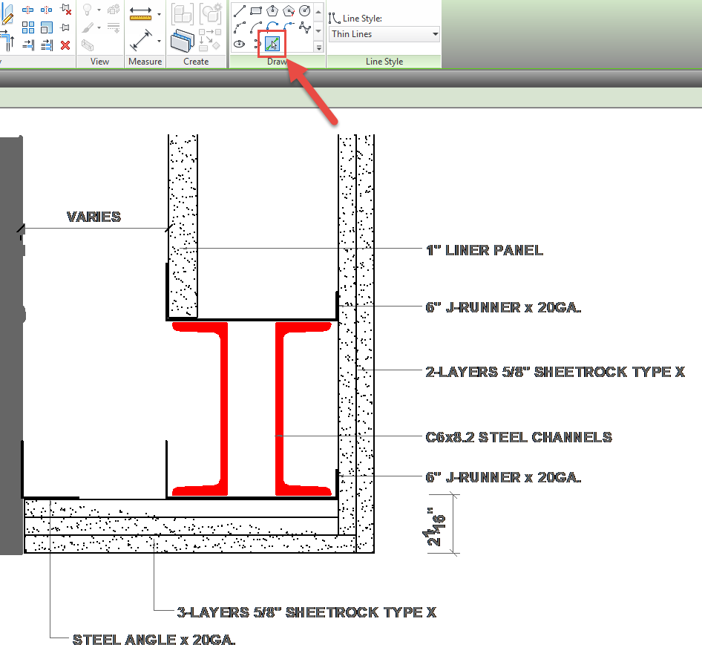

Figure 6.7‑1 Tracing DWG